
Ministry of Health
Disability, Rehabilitation and Occupational Safety & Health Division

Community Health Department

Community Health Worker (CHW) Facilitator’s Training Manual

on Eye Health
May 2025
A resource developed by the Ministry of Health and partners, in support of the National Community Health Strategy and Implementation Guidelines
Table of Contents
Overview 5
General Guidelines 5
Preparing for Training 6
Pre-Test for Eye Health 7
Section 1: Overview of Community-based Eye Health 8
Section 2: Role of CHWs and Other support structures 8
Section 3: Preparation and Tools for Eye Health Service Delivery 9
Section 4: Household Visits and Eye Health Promotion and Education 10
Section 5: Eye Screening Steps 13
Session 5.1: Overview of Eye Screening and Action Steps 13
Session 5.2: Practical Activity: Check Your Partner’s Eyes 21
Session 5.3: Practical Activity: Small Group CHW Skills Assessments 22
Section 6: Follow-up for Eye Health Promotion and Hygiene Practices 24
Section 7: Documentation and Reporting for Eye Health 27
Post-Test for Eye Health 29
Closing out Training and Distributing Reading Glasses 29

Overview
This Manual is designed to support trainers in building the capacity of Community Health Workers (CHWs) to promote, screen, and refer for eye health services in their communities, and dispense reading glasses to adults 40+ who need them. It aligns with the National Community Health Strategy and is based on the CHW Eye Health Job Aid developed by the Ministry of Health and partners.
The guide offers a training methodology that will facilitate your work in preparing CHW members for the work they will do. The training should be carefully planned, and well organized. Handling adult learners requires knowledge, care, and experience to give the VHT the skills needed to carry out their tasks.

General Guidelines
The following are general guidelines that will help you make training effective:

- Stick to the training guide and follow the activities as outlined.
- Encourage active participation. Trainees should speak more than the facilitator.
- Use probing questions to stimulate responses and discussion.
- Discuss content with co-facilitators in advance to harmonize delivery.
- Make sure materials and tools are prepared before sessions.
- Provide feedback and encourage peer-to-peer learning.

Preparing for Training

BEFORE TRAINING
Before training, ensure you have all of the supplies, printed materials, stationery and equipment needed for the training – listed below. If possible, try to prepare the training hall 1 day before.

Materials & Supplies Needed
Ensure you have the following materials prepared for training.
Item | Quantity Needed
- CHW Eye Health Toolkits (1 backpack, a 3-meter rope, 1 torch light + batteries, 1 mirror, 1 E-chart (for near and distance vision), 5 trial pairs of reading glasses (1 in each power) | 1 per VHT
- Integrated Community Health Worker Job Aid – Eye Health Module | 1 per VHT
- Notebooks | 1 per VHT
- Pens/pencils | 1 per VHT + 1 per trainer
- Training Agenda | 1 per VHT + 1 per trainer
- Registration Sheets for Day 1 & 2 | Sufficient for all participants
- Pre-Test  - Post-Test | 1 per VHT  1 per VHT
- Pre- and Post-Test Marking guide | 1 per trainer
- Community Health Worker (CHW) Facilitator’s Training Manual on Eye Health | 1 per trainer
- VHT Community Eye Health Register  - VHT Monthly Community Eye Health Service Report  - VHT Referral Forms  - Community Daily Consumption Logs  - Monthly Community Eye Health Summary Report | 1 per VHT  1 per VHT  1 per VHT  5 per VHT  1 per Health Assistant/CHEW
- Flip charts and masking tape | 2 per training
- Markers | 4 per training
- Initial stock of Reading glasses (with their corresponding soft pouches) for VHTs | 2 of each Stock Keeping Unit (SKU) per VHT

Remember, at the End of Training:
- You will distribute an initial supply of reading glasses, job aid and reporting tools to each VHT.
- You must record the quantity provided to each in the appropriate issue register (ensure you retain a copy)
- If the CHW received a pair of glasses for personal use during the screening, note this in the Community Daily Consumption Log

Pre-Test for Eye Health

DURATION: 20 minutes

METHODS/TECHNIQUES:

Written multiple choice test completed individually to assess existing knowledge of eye health

The facilitator should help the trainees to understand the questions and responses as needed

MATERIALS:

Pre-Test (1 per VHT)

Pens/pencils (1 per VHT)

Pre- and Post-Test marking guide (1 per trainer)

SESSION DEVELOPMENT:

Explain the rationale for a pre-test

Provide instructions and duration of the pre-test (15 minutes)

Explain the handling of pre-test results

Inform the trainees that there will be a post-test after the training

Section 1: Overview of Community-based Eye Health

LEARNING OUTCOMES
By the end of this topic, the trainees should be able to:
- Explain what eye health is and why it is important
- Understand the rationale for community-based eye health
- Explain the rationale for integrating eye health into routine Community Health Services

DURATION: 40 minutes

METHODS/TECHNIQUES:
- Brainstorming
- Group discussion
- Explanation & demonstration
- Question and answer

MATERIALS:
- Integrated Community Health Worker Job Aid – Eye Health Module
- Flip chart and markers, masking tape

SESSION DEVELOPMENT

Introduction Phase
Ask the trainees to:
- Share what they understand by a healthy eye.
- Share if any of them have personally experienced eye problems, and how that impacted their lives.
- Share if they have met people with eye health problems in their communities and how they knew they had an eye problem.
- Share how people with eye problems in their communities get treatment or care.

Explanation and demonstration
Refer to Section 1 (pages 4-8) of the job aid for eye health
Demonstrate and explain:
- What is eye health and why is it important?
- Give an overview of the need to bring eye care services at community level
- Background and rationale of eye health integration into CHW package of services
- Emphasize it is not a stand-alone activity, but should be integrated into their routines

Question and answer:
Give room for the trainees to ask questions on the subjects covered.

Section 2: Role of CHWs and Other support structures

LEARNING OUTCOMES
By the end of this session, the trainees should be able to:
- List key community stakeholders that can support eye health service
- List their roles and responsibilities in eye health
- List other non-community support structures (e.g. health facilities, Ophthalmic Clinical Officer etc)
- Understand how to collaborate with support structures for eye health

DURATION: 20 minutes

METHODS/TECHNIQUES:
- Brainstorming
- Group discussion
- Explanation & demonstration
- Question and answer

MATERIALS:
- Integrated Community Health Worker Job Aid – Eye Health Module
- Flip chart and markers, marking tape

SESSION DEVELOPMENT

Introduction Phase:
Ask the trainees to:
- Share what they think their roles and responsibilities could be in eye health
- List the structures/people (community and facility) they usually work with while doing their day-to-day work as CHWs
- Share what roles those support structures usually play in supporting them do their work

Explanation and demonstration
Refer to Section 2 (pages 9-11) of the job aid for eye health
Explain:
- The role and responsibilities of the CHWs in eye health
- The role and responsibilities of other community-level stakeholders in eye health
- The roles and responsibilities of CHW support structures in eye health
- Emphasize collaboration among stakeholders

Question and answer:
Give room for the trainees to ask questions on the subjects covered.

Section 3: Preparation and Tools for Eye Health Service Delivery

LEARNING OUTCOMES
By the end of this session, the trainees should be able to:
- List the essential tools they need to be able to carry out eye health activities
- Explain the role of each of the components of the eye health tool kit and storage
- Make an eye shield for severe eye emergencies in the community/field
- Effectively prepare to deliver eye health services in both outreach and household settings

DURATION: 40 minutes

METHODS/TECHNIQUES:
- Brainstorming
- Group discussion
- Explanation & demonstration
- Question and answer

MATERIALS:
- Integrated Community Health Worker Job Aid – Eye Health Module
- Flip chart and markers
- CHW tool kit for eye health

SESSION DEVELOPMENT

Introduction Phase

Ask the trainees to:
- List some of the tools they use most often in their day-to-day work as CHWs
- State the role of each of the components of the eye health tool kit
- Share what preparatory steps they do when planning a household visit
- What preparatory steps they do when planning an outreach

Explanation and demonstration
Refer to Section 3 (pages 12-16) of the job aid for eye health
Demonstrate and explain:
- Pick up each component of the CHW tool kit for eye health services one by one, and discuss what it is used for
- Demonstrate how to make an eye shield for severe eye emergencies in the community/field
- How to prepare to deliver eye health services in household and outreach settings

Question and answer:
Give room for the trainees to ask questions on the subjects covered.

Section 4: Household Visits and Eye Health Promotion and Education

LEARNING OUTCOMES
By the end of this session, the trainees should be able to:
- Mobilize and sensitize communities on eye health services.
- List common myths and misconceptions from community members and how to address them effectively.
- Share key eye health messages during household visits.

DURATION: 1 hour (60 minutes)

METHODS/TECHNIQUES:
- Group discussion
- Explanation & demonstration
- Role play
- Question and answer

MATERIALS:
- Integrated Community Health Worker Job Aid – Eye Health Module
- Flip chart and markers
- Notebooks
- Pens/Pencils

SESSION DEVELOPMENT

Introduction Phase
Discuss the following questions with the VHTs:
- How do you think people in your community will feel about receiving eye care services from you?
- What questions might they have and how would you address them?
- What do you think might be some of the myths and misconceptions in your community related to eye health or wearing glasses?
- What are some things to consider as you prepare to conduct community mobilization and sensitization for eye health services?

Explanation and demonstration (40 minutes)
Refer to Section 4 (pages 17-22) of the job aid for eye health
- Provide an overview of the household eye health visit
- Demonstrate and explain the steps of conducting household eye health visit
  - Greet the household in a warm, friendly way
  - Define the purpose of the household visit
  - Provide eye health education to everyone
    - Why eye health is important to the household member
    - How near vision becomes difficult with age, and how it can affect individuals
      - Emphasize different age groups have different eye health problems, and hence different screening tests
    - Key messages for normal eye
- Discuss how to address examples of common myths and misconceptions provided by VHTs in the group discussion. Some examples are provided below:
  - MYTH: Use of glasses can make a person blind.
    - Response: Emphasize that glasses are important for correcting vision and if used properly, as prescribed by a trained health worker, they do not cause blindness.
  - MYTH: Glasses are only for old people or rich people.
    - Response: Anyone at any age might need glasses to help them see clearly. Eye health problems affect the rich, the poor, the young, and the old. Eyeglasses can be afforded by anyone.
  - MYTH: Traditional medicine (cow dung, breastmilk, saliva, urine) can treat eye problems.
    - Response: No, the use of these actually worsens eye problems. In case of any eye problems, contact your VHT or visit the nearest health facility.
  - MYTH: You must be literate to use reading glasses.
    - Response: Reading glasses can help you see clearly when doing near tasks, such as sewing, counting money, sorting rice, and using your phone.

Question and answer
Give room for the trainees to ask questions on the subjects covered.

Section 5: Eye Screening Steps

Facilitator Notes
- This Section focuses on demonstrating in detail each step in the Eye Screening procedure, along with orientation to the data collection forms and reporting procedures that VHTs will use for community-based eye health service delivery.
- For each step, include discussion of the service delivery and the data collection component, as relevant.
- You will ask for a volunteer to serve as a household member during the demonstration, and you will borrow the volunteer’s Eye Health toolkit to use for the demonstration.
- Make sure all participants have copies of the VHT Community Eye Health Register, VHT Referral Form, VHT Monthly Community Eye Health Service Report, Community Daily Consumption Log and the Job Aid.

Session 5.1: Overview of Eye Screening and Action Steps

LEARNING OUTCOMES
By the end of this session, the trainees should be able to:
- Explain all the steps of eye health screening and action, including:
- Step 1: Asking Key Questions and Taking Appropriate Action
- Step 2: Setting Up Space and Washing/Disinfecting Hands
- Step 3: Explaining and Demonstrating Screening & Use Of Charts
- Step 4: Conducting Simple Eye Check with Torch Light
- Step 5: Conducting Simple Distance Vision Test
- Step 6: Conducting Simple Near Vision Test
- Step 7: Dispensing Reading Glasses
- Step 8: Preparing for Next Household Member
- Identify what a normal and abnormal eye looks like
- Provide health education about using and caring for reading glasses for those who receive them

DURATION: 2 hours (120 minutes)

METHODS/TECHNIQUES:
- Explanation & demonstration
- Question and answer

MATERIALS:
- Flip charts
- Markers
- Chair
- Integrated Community Health Worker Job Aid – Eye Health Module
- CHW Eye Health Toolkits
- VHT Community Eye Health Register
- VHT Referral Forms
- Community Daily Consumption Logs

SESSION DEVELOPMENT

Step 1: Asking Key Questions and Taking Appropriate Action
Refer to Section 5, Step 1 (pages 24-27) of the job aid
- Explain: Some eye conditions may require referral for further assessment, can indicate other diseases that may need medical attention, or could mean that someone is at higher risk for eye conditions in the future, which is why the screening begins with some key questions.
- Review with trainees the Key Questions and Appropriate Actions for each age group, as outlined in the job aid.
- Ask trainees to look at their VHT Community Eye Health Register and follow along during the remaining steps of the demonstration.
- Acting as a VHT:
  - Demonstrate how you will first record the date and the volunteer household member’s information in your VHT Community Eye Health Register, by asking:
    - Name
    - Household ID
    - Age
    - Gender
  - Ask the volunteer household member each of the Key Questions appropriate for their age in Section 5, Step 1.2 of the job aid, and make note of their responses.
- Explain the actions you would take based on their responses, referring to Section 5, Step 1.2 of the job aid.
- Demonstrate how you would record the outcome in the VHT Community Eye Health Register, and complete a VHT Referral Form as needed.
  - If the client does NOT require referral for any of the Key Questions, they PASS, and you should:
    - RECORD “Y” under “Key Questions - PASS?” in VHT Community Eye Health Register and proceed.
  - If the client requires a referral for any of the Key Questions, you should:
    - RECORD “N” under “Key Questions - PASS?” in VHT Community Eye Health Register and indicate “Y” in the column titled “Referred?”.
    - Complete a Referral Form indicating the reason for referral.
    - Only if indicated in the job aid, proceed with the remaining screening steps.
- Discuss any questions or clarifications that trainees have about Step 1.

Step 2: Setting Up the Space and Washing/Disinfecting Hands
Refer to Section 5, Step 2 (page 28) of the job aid


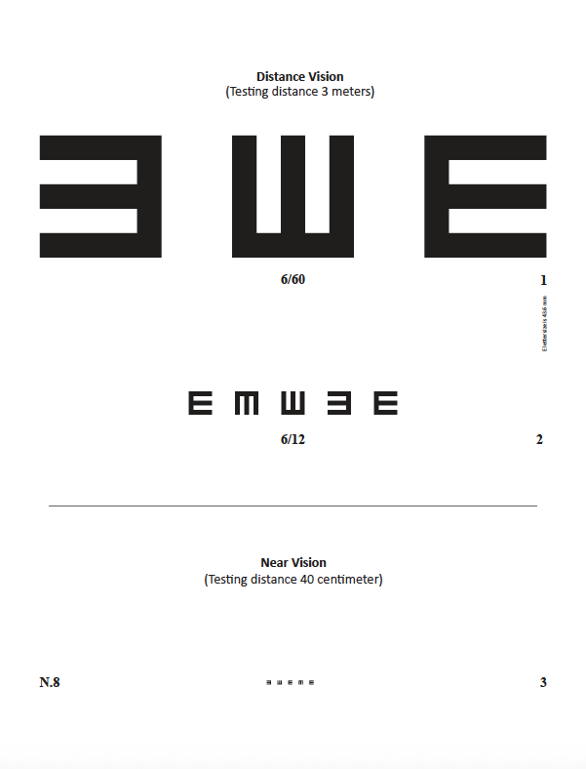
- Explain: Before proceeding with the eye screening, it’s important to set up the space properly. You need to select a space with good ventilation and good lighting (not too dark, sun not shining in eyes).
3 meters
- Demonstrate setting up the space:
  - Place a chair in front of the class, where trainees can see.
  - Place the 3-meter pre-measured rope in your tool kit on the ground near the center of the chair and mark its two ends with tape. If a wall is available to place the E-chart, arrange the chair so that the client will be sitting 3 meters from the chart on the wall, using the rope to measure. Adhere the E-chart to the wall.
  - If there is no suitable wall (or adhesive) available, mark where you will stand using the rope and hold up the distance vision chart.
  - The chart should be at the same level as the eyes.
  - Ask the volunteer household member to sit in the chair or stand straight.
- Note that if VHT is hosting a community screening day, the vision testing area should be separated from the waiting area and you should call only one client at a time for vision testing.
- Explain: Before proceeding with the eye screening, wash your hands with clean water and soap. If water and soap are not available, use a disinfectant.
- Discuss any questions or clarifications that trainees have about this step.

Step 3 – Explaining and Demonstrating Screening & Use Of Charts
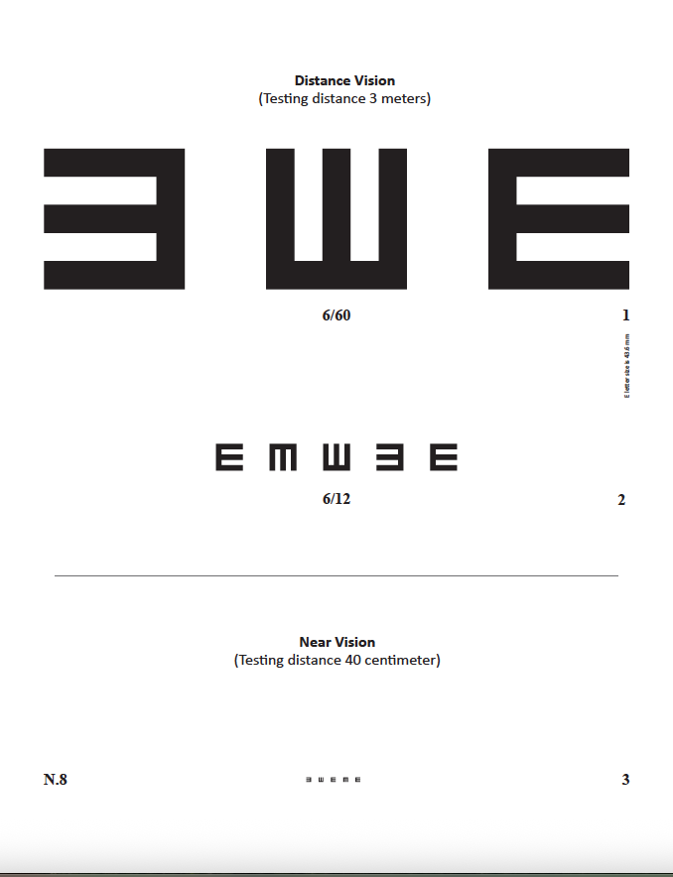
Refer to Section 5, Step 3 (page 29) of the job aid
E-chart for Testing Distance and Near Vision
Distance Vision
Near Vision
Explain and demonstrate:
- Explain: There are three basic tests to assess someone’s eyes, which vary with age. These include;
- Simple Eye Check (for all ages)
- Simple Distance Vision Test (for those aged 6 years and above)
- Simple Near Vision Test (for those aged 6 years and above)
- To conduct distance and near vision test, you will use an E-chart.

- Explain to trainees the three lines of E’s on the E-chart. The top two lines are for testing distance vision. The bottom line is for testing near vision.
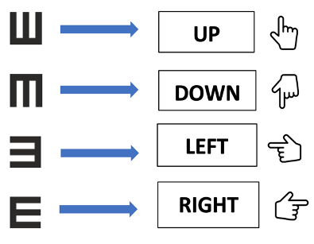
- Demonstrate for trainees how to use the E-chart (stool with three legs) to show the household member what the E’s will look like and how to indicate which way the open ends of the E are facing. Household members should indicate which way the “legs” of the E are facing.
Key for Demonstrating Direction of E’s
- Ask trainees to demonstrate: “Up” E, “Down” E, “Left” E and “Right” E hand gestures.

- Demonstrate: For the Simple Eye Check using torch light(all ages):
  - Acting as a VHT, explain to the volunteer household member that you will examine the outside of their eyes using a torch light to look for signs of an eye problem
- Demonstrate: For the Simple Distance Vision Test (ages 6+):
  - Acting as a VHT, explain to the volunteer household member how you will test one eye at a time, with the client covering the other eye gently with the palm of the hand
  - If the client has spectacles for seeing far, you will check distance vision while the client is wearing the spectacles.
  - However, if the spectacles are for reading only (or seeing close), you will not use them to check distance vision
- Demonstrate: For the Simple Near Vision Test (ages 6+):
  - Acting as a VHT, explain to the volunteer household member how you will test both eyes at the same time (both eyes open)
  - Ensure the household member understands and is comfortable before proceeding.
- Discuss any questions or clarifications that trainees have about Step 3.

Step 4 – Simple Eye Check with Torch Light (All Ages)
Refer to Section 5, Step 4 (pages 30-33) of the job aid


- Explain the purpose of the Simple Eye Check with Torch Light, how it works, and that VHTs will conduct the test with household members of all ages.
- Ask trainees and discuss:
  - What does a normal eye look like? (Refer to page 31 for pictures of normal eye)
    - Make sure to cover all of the points included in the job aid.
  - What are some things we would look for that would indicate an eye problem? (Refer to page 34 for pictures of an abnormal eye)
    - Make sure to cover all of the points included in the job aid.
- Demonstrate:
  - Acting as a VHT, demonstrate with the volunteer household member how you will look at each eye to see if there are any obvious signs of a health problem and then shine the torch from the side of the person’s eye and move the torch across the eye. Avoid shining the torch for longer than 5 seconds into the person’s eye.
- Explain that if you do not see any signs of an eye health problem, you should do the following based on the client’s age:
  - If the client is below age 6, Record the outcome in the VHT Community Eye Health Register and CONCLUDE the visit.
  - If the client is age 6 or older, Record the outcome in the VHT Community Eye Health Register, WAIT 2 minutes to allow the eye to recover from bright light and proceed to Step 5.
- Explain that the volunteer household member does not appear to have any signs of eye health problems and the next steps you would take.
- Record the outcome in the VHT Community Eye Health Register.
  - Ask trainees: How would you record this in the register?
  - Ask trainees: If I see any problems in the person’s eye, what steps should I take?
    - EXPLAIN to the client that there is a problem.
    - RECORD “N” in the register: “Eye Exam w/ Torch Light – Pass?”
    - RECORD “Y” in the register: “Referred?”
    - STOP the screening and REFER to health facility for additional examination, using the VHT Referral Form.
- NB: Emphasize to the trainees not to use phone light for doing the torch light test as the brightness may be inconsistent, and it is not suitable for this purpose.

- Explain that VHTs should NEVER:
  - Give eye drops, ointment, or any other treatment
  - Recommend traditional eye medications (e.g., cow dung, urine, breastmilk, saliva)
  - Encourage traditional beliefs (e.g., witchcraft)
- Discuss any questions or clarifications that trainees have about Step 4.

Step 5 – Simple Distance Vision Test (ONLY Ages 6+)
Refer to Section 5, Step 5 (pages 34-35) in the job aid

- Explain that you will now test the household member’s distance vision using only the top two lines of the E chart for this test.
  - Because the household member is over age 6, I know I should check them for distance vision.
  - Remember, if the client has spectacles, check distance vision while the client is wearing the spectacles.
  - However, if the spectacles are for reading only, do not use them to check distance vision.
- Demonstrate: Acting as a VHT, stand next to the distance vision chart placed at a 3-meter distance from the household member.
  - Ask them to cover their left eye first, to check their RIGHT eye.
  - Point to each ”E” on the first line (6/60) one at a time and ask the client to indicate the direction (Up/Down/Left/Right).
  - If at least two letters on the first line are correctly identified, you can proceed to the next part of the distance vision screening.
  - If one or no letters are correctly identified, the client fails:
    - STOP the test
    - REFER to a health facility for additional examination
    - Ask trainees:
      - How would you record this outcome in the VHT Community Eye Health Register?
        - Record N in the register under “Distance Vision Test - Pass?”
        - Record Y in the register under “Referred?”
      - How would you complete the VHT Referral Form?
        - Complete the form as usual, including “Fail of distance vision test” as the reason for referral.
- Explain that the household member did not fail the first part of the distance vision screening, so you will complete the same procedure again with the RIGHT eye, but this time using the second line on the E chart (6/12).
  - If 4 or more letters on the second line are correctly identified, the client passed and I will RECORD “Y” in the register under “Distance Vision Test - Pass?”
  - If 3 or fewer letters are identified, the client failed and I record and refer as outlined above.
- Explain that if the household member passed distance vision screening for the right eye, you will then repeat the steps above for the LEFT eye.
- Demonstrate completing the procedure for the LEFT eye with the volunteer household member.
- Ask trainees to record the outcome of the demonstration in their copy of the VHT Community Eye Health Register. Have them review their ledger with another VHT sitting next to them.
- Explain that you are going to check their understanding of the procedure once more.
- Demonstrate:
  - Hold up the E-chart and point to the top line (6/60).
  - Indicate that the client got 2 out of 3 correct on line 1.
- Ask trainees: Would she pass or fail this step?
  - She would PASS, because she correctly identified 2 letters.
- Demonstrate:
  - Hold up the E-chart and point to the second line (6/12).
  - Indicate that the client got 3 out of 5 correct on line 2.
- Ask trainees:
  - Would she pass or fail this step?
    - She would FAIL, because she correctly identified only 3 out of the 5 E’s.
  - What should I do in that case?
    - Record and refer.
- Discuss any questions or clarifications that trainees have about Step 5.
NB: For a client to pass the Simple Distance Vision test, they should miss only one letter on each line.

Step 6 – Simple Near Vision Test (ONLY Ages 6+)
Refer to Section 5, Step 6 (page 36) of the job aid

Facilitator Notes
- At the end of the Simple Near Vision Test demonstration, you will pretend the volunteer client has failed the near vision test (even if they have not), so we can proceed to demonstrate dispensing of reading glasses.

- Ask trainees: Before we get started, as a refresher, who in the community do we test for near vision?
  - Clients age +6 who:
    - PASSED the Simple Eye Check, AND
    - PASSED the Simple Distance Vision Test
- Explain that for near vision screening you will test both eyes at the same time. If client wears spectacles for ONLY seeing up close, you will ask the client to wear their spectacles for test.
- Demonstrate:
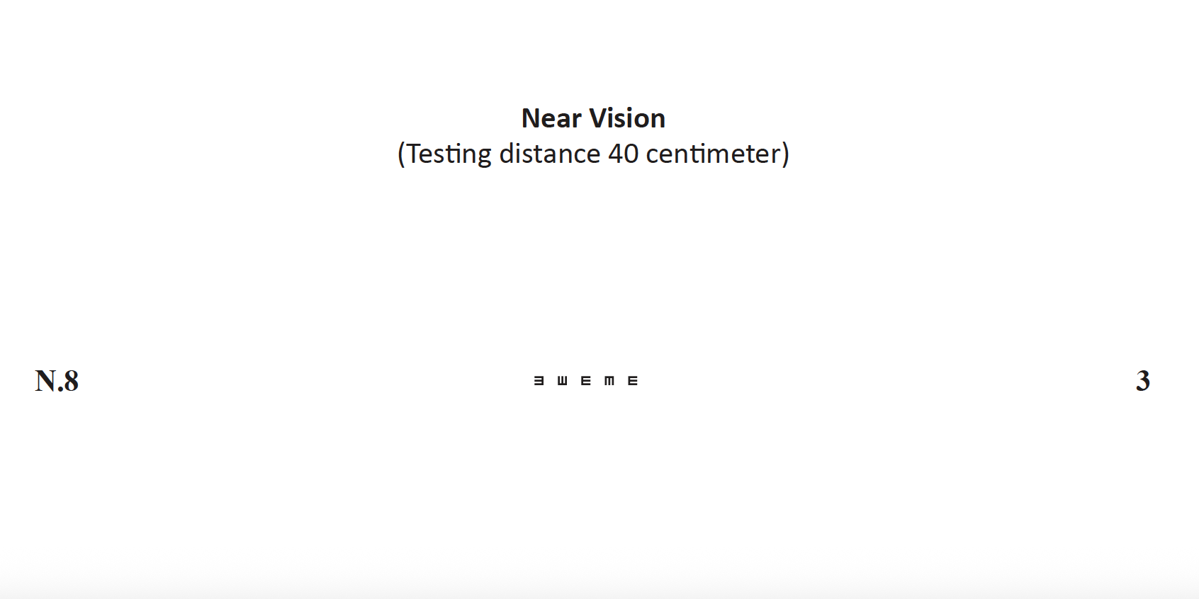
  - Acting as the VHT, hand the E-chart to volunteer household member and ask them to hold it at arm’s length -- which is about 40 cm.
  - Ask them to look at row N8, which is the bottom row and tell you which way the legs are facing.
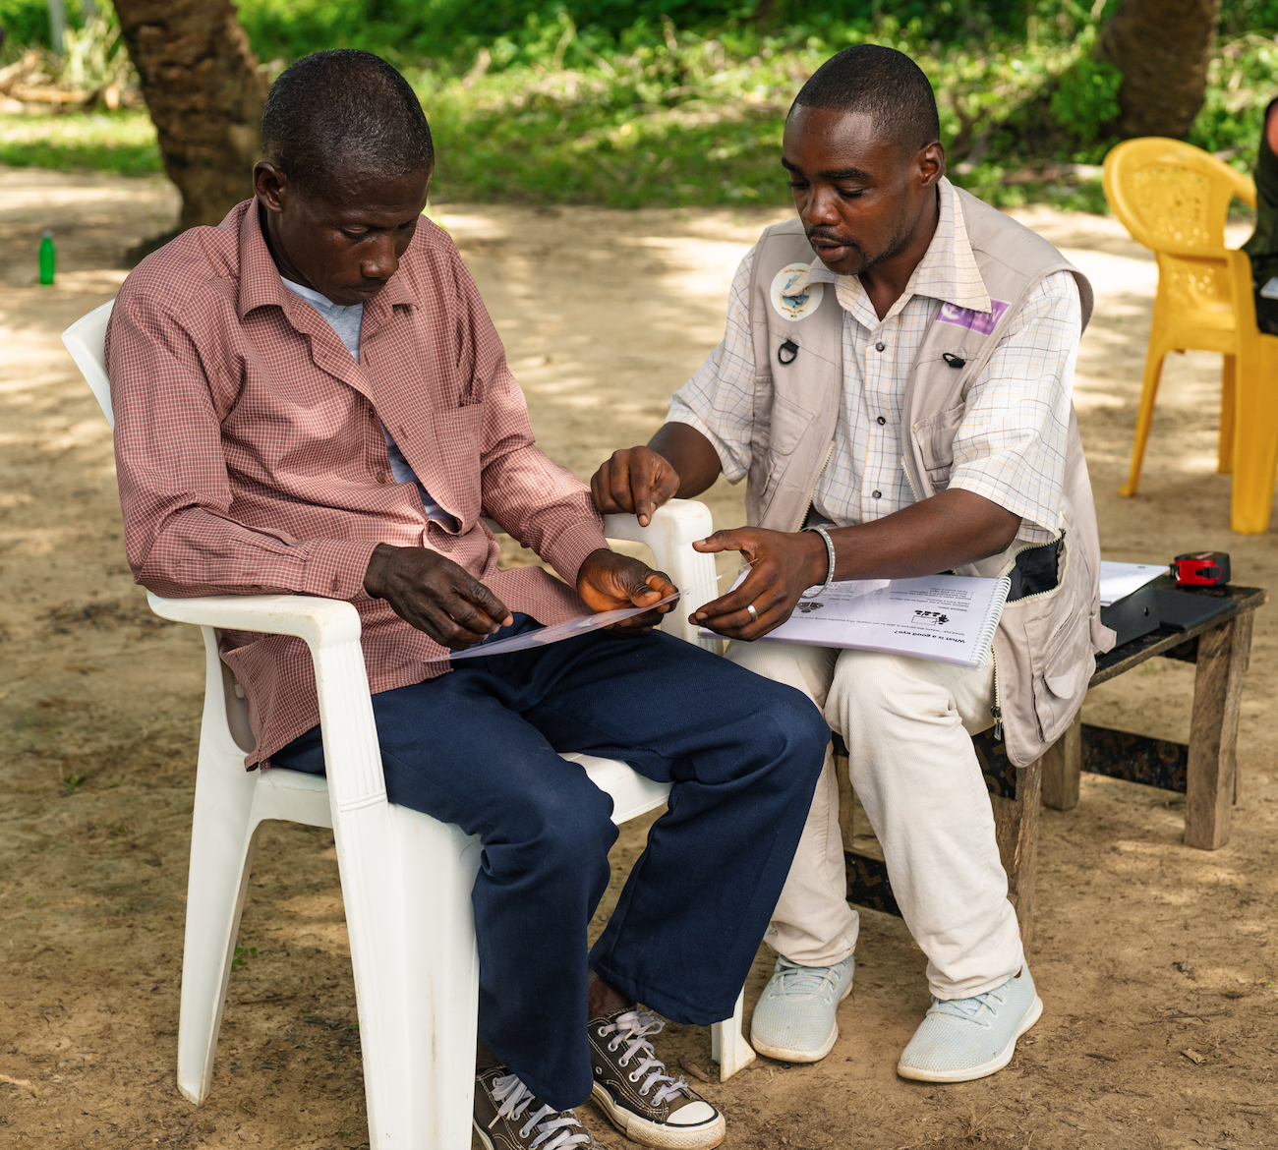
  - If the client can see row N8 clearly, they pass the Near Vision Test, and you should:
    - Record Y in the register under ‘Near Vision Test – PASS?’
    - Conclude the visit
  - If the client cannot see row N8 clearly, they fail the Near Vision Test. The next steps depend on the client’s age.
    - If the client is age 6-39, you should:
      - Record N in the register under ‘Near Vision Test – PASS?’
      - REFER to a health facility for further assessment.
    - If the client is age 40+, you should:
      - Record N in the register under ‘Near Vision Test – PASS?’
      - Proceed to Step 7 to dispense reading glasses.
  - Explain that for the purposes of this demonstration, you will pretend that the household member has failed the near vision test (even if they haven’t), so that we can demonstrate dispensing reading glasses.
- Discuss any questions or clarifications that trainees have about Step 6.

Step 7 – Dispensing Reading Glasses (ONLY Ages 40+)
Refer to Section 5, Step 7 (pages 37-42) of the job aid.

Facilitator Notes
- Before beginning to demonstrate this step, pass out a few pairs of reading glasses in different powers and styles to the trainees so they can take a look at them. Ask trainees to pass the glasses around the room, and then keep them at their tables to refer to during the session.
- Also ensure each trainee has their 5 copies of the Community Daily Consumption Log available for the session.

Learning About Reading Glasses
- Ask trainees:
- Can anyone tell me the criteria for who we test for reading glasses?
  - Clients age 40+ who:
    - PASSED the Simple Eye Check,
    - PASSED the Simple Distance Vision Test, AND
    - FAILED the Simple Near Vision Test
- Explain: Before getting started with the demonstration, it’s important to understand a bit more about reading glasses.
  - Reading glasses have different powers and styles.
  - The power of the lenses determines how much bigger text or objects will look.
  - VHTs have five powers of reading glasses: +1.00, +1.50, +2.00, +2.50, and +3.00.
  - Stickers on the lenses show the power. When you dispense a pair of reading glasses you can remove the sticker.
  - VHTs will test clients’ eyes to see what power they need.
  - The higher the power, the bigger text or objects will look.
  - As they get older, people may need to switch to a higher power.
  - You will also see different styles of reading glasses in your stock. Clients should take whatever glasses fit them best in the correct power.
- Explain that reading glasses have two main parts (reference the sample pairs of reading glasses):
  - The lenses, which is the part that people look through.
  - The frame, which includes (referencing the photo below):
    - Rims, which hold the lens in place.
    - The bridge, which joins the two rims and sits above the person’s nose.
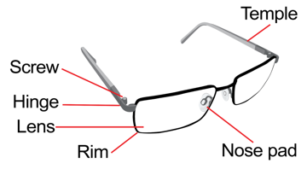
    - Nose pads, which are small plastic pieces that sit on either side of the person’s nose and keep the glasses in a comfortable position.
Bridge
    - The temples, which extend from the rim to each side of a person’s head and over their ears.
    - The hinge, which has screws that allow the glasses to be folded when not in use.
  - Emphasize that reading glasses should always be placed down on their frames, never on lenses. Additional education for clients who receive reading glasses is in Section 5, Step 7 of the job aid.
- Ask trainees to look at their Community Daily Consumption Logs.
  - Explain: VHTs will have one Community Daily Consumption Log for each power of reading glasses; so 5 in total.
  - Ask trainees to prepare their Community Daily Consumption Logs – one for each of the five powers.
    - Indicate the power under Section (8) NAME OF ITEM (Name, Strength, Formulation), by writing, e.g.:
      - “Reading glasses, +1.00”
    - Under Section (9) DISPENSING UNIT, you will indicate:
      - “Pair”
- Ask if trainees have any questions about this information.

Dispensing Reading Glasses

- Explain that Dispensing Reading Glasses involves a couple of steps, including finding the right power, finding the right fit, and recording the dispensing in the Community Eye Health Register and Community Daily Consumption Log.
- Ask trainees:
  - What tools do we need from our toolkits to test and dispense reading glasses?
    - Job aid
    - E-chart (Near Vision section - third line/N8)
    - Sample reading glasses (1 each in power +1.00, +1.50, +2.00, +2.50, and +3.00)
    - Supply of reading glasses
    - Reading glasses cases and/or soft, clean cloth
    - Mirror
- Demonstrate:
  - Acting as the VHT, start by asking the volunteer household member to hold the E-Chart at arm’s length and try on the sample pair of +1.00 reading glasses.
  - Ask if they can see row N8 clearly (use BOTH EYES)
    - If they can see row N8 clearly with the +1.00 power sample glasses, move on to the next step.
    - If they cannot see row N8 clearly with +1.00 power sample glasses, proceed to test the other powers of sample glasses (+1.50, +2.00, +2.50, and +3.00) with them in the same way, until you find the correct power for them.
- Explain that it is possible that you will try the all 5 powers and none of them will work. In that case:
  - RECORD “Y” in the register: “Referred?”
  - STOP the test
  - REFER to health facility for additional examination using the VHT Referral Form.
- Explain that for this demonstration, you will pretend that the volunteer household member needs reading glasses with +1.50 power, and you will now help them try on the different reading glasses you have in available that match the power they need. Select the pairs of +1.50 glasses that you have in stock.
- Demonstrate
  - Hand the mirror to the client and ask them to try on each of the pairs of +1.50 glasses
  - Ask them:
    - If the glasses feel comfortable (not pinching).
    - To move their head up and down and check the glasses stay in place.
  - Once you find the right fit, dispense, record, and advise.
  - Since my client found a pair of reading glasses with the right power and fit:
    - Record “Y” in the Register under “Dispensed Glasses - +1.50” and give the client the glasses and glasses case.
    - Record the item and power dispensed in your Community Daily Consumption Log for Reading glasses, +1.50 (see Section 7 of the manual and job aid for more information on recording dispensing).
  - Teach the household member about how to use and care for the reading glasses (refer to Pages 41-42 in the job aid) and tell them to let you know if they have any problems with the glasses. You can note that if for some reason the client does not have an appropriate case for their glasses, they can wrap the glasses in a clean cloth and keep them in a safe place.
  - If none of the glasses fit well, refer to the health facility for additional examination.
- Discuss any questions or clarifications that trainees have about Step 7.

Step 8 – Prepare for the Next Household Member
Refer to Section 5, Step 8 (page 43) of the job aid.

- Explain that before welcoming the next household member for eye screening, you will disinfect any supplies that the household member touched, including the E-chart, sample glasses, mirror, and any glasses that the client tried on, but did not select. You will also wash your hands.
- Begin a new line on the VHT Community Eye Health Register for the next household member.
- Discuss any questions or clarifications that trainees have about Step 8 or the overall Eye Screening Steps.

Session 5.2: Practical Activity: Check Your Partner’s Eyes

LEARNING OUTCOMES
By the end of this session, trainees should be able to:
- Perform all the steps of eye health screening and action, including:
- Step 1: Asking Key Questions and Taking Appropriate Action
- Step 2: Setting Up Space and Washing/Disinfecting Hands
- Step 3: Explaining and Demonstrating Screening & Use Of Charts
- Step 4: Conducting Simple Eye Check with Torch Light
- Step 5: Conducting Simple Distance Vision Test
- Step 6: Conducting Simple Near Vision Test
- Step 7: Dispensing Reading Glasses
- Step 8: Preparing for Next Household Member
- Complete the accompanying data collection forms with correct information

DURATION: 1 hour (60 minutes)

METHODS/TECHNIQUES:
- Practical activity
- Question and answer

MATERIALS:
- Integrated Community Health Worker Job Aide – Eye Health Module
- CHW Eye Health Toolkits
- Reading Glasses
- VHT Community Eye Health Register
- VHT Referral Forms
- Community Daily Consumption Logs

SESSION DEVELOPMENT
- Demonstrate the entire screening process on your colleague (fellow trainer) over 10-15 mins at the beginning of the session.
- Ask the trainees to pair up and explain that each will take turns screening the other’s eyes to practice the Steps 1-8 of the Eye Screening AND to assess their colleagues’ eye health and provide glasses or referrals as needed.
- Explain that they will use the Job Aides, Community Eye Health Toolkits, data collection forms and reading glasses to complete the activity.
- For each step along the way, they should complete the appropriate documentation and reporting tools:
- Community Eye Health Register,
- Referral Form, or
- Daily Consumption Log, as indicated.
- For any CHW who requires reading glasses, they can be dispensed on the spot, using the available inventory. This should be clearly recorded in the appropriate forms, and they should receive 1 less of that SKU in their initial stock.
- Trainees will have 50 minutes for this exercise, so ensure they split the time so that each person has time to conduct the Eye Screening Steps.
- Make sure to spend time on each step to truly practice and understand what is involved.
- You, the facilitator, will move around to each group to observe, provide feedback, and respond to any questions about the activity. Make sure to spend time with each pair.
- If trainees have questions as they proceed, they can ask the facilitator.

DEBRIEF ON THE ACTIVITY
Facilitator Notes
- This is an opportunity to share some of your reflections and observations of the Practical activity, as well as to hear feedback and questions from the CHWs.
- This is also a good opportunity to see if many or most CHWs are finding any of the steps in the procedure or information shared so far difficult to grasp.
- Note down anything that comes out as particularly challenging. This will be important to share with the Community Health Department at the Ministry of Health and other pilot stakeholders.
- Ask the following:
- Would anyone like to share with the group something you found particularly helpful, challenging, or noteworthy during the Practical Activity?
- Do you have any questions or clarifications about the procedure, the tools, or any aspect of the training so far?

Session 5.3: Practical Activity: Small Group CHW Skills Assessments
Facilitator Notes
- During this session, you still split trainees into five groups of equal size.
- Before the session begins, select one person from each group to serve as the household member in the scenario.
- Share the “Skills Assessment Case Studies – Client Script” for their group’s scenario with them and ask them to familiarize themselves with how they should respond when prompted by the other group members (who will work together, acting as the VHT).
- Allow the volunteer household member 10 minutes to familiarize with the script.

LEARNING OUTCOMES
By the end of this session, trainees should be able to:
- Demonstrate understanding of how to complete eye screening for various individuals in the community

DURATION: 2 hours (120 minutes)

METHODS/TECHNIQUES:
- Role play
- Group discussions
- Question and answer

MATERIALS:
- Integrated Community Health Worker Job Aide – Eye Health Module
- CHW Eye Health Toolkits
- Reading Glasses
- VHT Community Eye Health Register
- VHT Referral Forms
- Community Daily Consumption Logs
- Skills Assessment Case Studies
- Skills Assessment Case Studies – Client Script

SESSION DEVELOPMENT
- Explain that this is a small group session, providing trainees with an opportunity to use the case studies to demonstrate their skills and get peer and facilitator feedback.
- Divide the trainees into five groups of equal size and allocate one scenario from Skills Assessment Case Studies (in the Annex) to each group.
- Explain:
- One member of each group is role playing as the client, and they have a specific script to follow, as prompted by the VHT. As a group, you are representing the VHT, working together to move through the appropriate screening steps for the client. As a group, you can discuss and determine how to proceed, based on the job aid and your training.
- Groups should determine together how to handle and manage the client, based on the information that the client shares throughout the interaction.
- Summarize all steps and actions taken by the group.
- Ensure each group understands the case they are handling and the instructions of what they have to do.
- Explain that the group will be evaluated based on:
- Correct steps taken
- Questions asked
- Appropriateness of actions (test, dispense, refer etc)
- Documentation
- After each group has presented its role play, ask the rest of the team to comment/ask questions.
- Provide feedback to each group, referencing the Facilitator Notes below.
Facilitator Notes
Facilitator Notes: Case Study 1 – Madiinah
- CHW should do the appropriate procedures for her age: history taking, torch light test, distance vision test, and then referral for further assessment for her itchy, red eyes.
- CHW should not do near vision test.
- All her information should be captured in the registers appropriately.
Facilitator Notes: Case Study 2 – Gerald
- CHW should do all the appropriate procedures for his age: history taking, torch light, distance vision, near vision, dispensing reading glasses (if an appropriate power and fit are found), and educating on how to take care of his glasses.
- He should still receive the reading glasses, even though he already has the distance vision glasses.
- Ensure all the information is captured in the register and consumption log.
Facilitator Notes Case Study 3 – Rose
- Although Rose has itchy eyes, she does not have a danger sign and so should proceed to conduct all the tests, fill in the register; and get referred after receiving the reading glasses and education on how to care for them
Facilitator Notes: Case Study 4 – Sarah
- For the mother, CHW should carry out the appropriate procedures for her age: history taking, torch light test, distance vision test. No referral is needed for the mother.
- For the baby, CHW should do only history taking (from the mother), torch light test, and refer to the health facility for further examination.
- In both cases, CHW should ensure to fill the register accordingly. Mother should have her own line, baby also her own line.
Facilitator Notes: Case Study 5 – Mukasa
- CHW should do the appropriate procedures for his age: history taking, torch light, and distance vision test.
- Because he fails the distance vision test, he should be referred to health facility.
- All information should be recorded appropriately.

Section 6: Follow-up for Eye Health Promotion and Hygiene Practices
LEARNING OUTCOMES
By the end of this topic, the trainees should be able to:
- Demonstrate knowledge of how and when to conduct a follow-up eye health visit, which individuals should be targeted, and what to look out for during the visit
DURATION: 1 hours (60 minutes)
METHODS/TECHNIQUES:
- Group discussion
- Explanation and demonstration
- Role play
- Question and answer
MATERIALS:
- Integrated Community Health Worker Job Aid – Eye Health Module
- VHT Community Eye Health Register (Follow Up section)
- Flip chart and markers
- Notebooks
- Pens/Pencils
SESSION DEVELOPMENT
Introduction Phase
- Ask the VHTs to brainstorm in small groups on the following questions:
- What is the importance of follow up for eye health?
- When do we do follow up?
- Who do we follow up with?
- What do we check for during follow-up for eye health?
- Discuss with the larger group
Explanation and demonstration
Refer to Section 6 (pages 44-48) of the job aid
- Explain how to conduct the following follow-up scenarios, including taking appropriate action as needed:
- Scenario 1: Follow up on eye health promotion and hygiene practices (refer to Section 6.1, page 45 of the job aid)
- Scenario 2: Follow up for household members who received reading glasses (refer to Section 6.2, pages 46-47 of the job aid)
  - Emphasize the problems to look out for:
    - Headaches
    - Close-up objects have become hard to see again
    - Needing to hold objects or reading material too close or too far away to see them clearly
    - Reading glasses are lost, broken, or scratched
    - Emphasize that VHTs should repeat the Eye Screening Steps if a person cannot see as they did before (refer to Section 5 of the job aid).
- Scenario 3: Follow up for household member who was referred for eye health (refer to Section 6.3, page 48 of the job aid)
  - Emphasize VHTs can conduct the Eye Screening Steps for household members who were referred (without completing screening), completed their referral, and were not screened for distance or near vision at the facility (refer to Section 5 of job aid).
- Demonstrate how to fill out the Follow Up section of the Community Eye Health Register for each scenario.
Role play
- Ask for six volunteers (two for each scenario) to demonstrate each follow up scenario:
  - Reinforcing eye health promotion and hygiene practices
  - Household member who received reading glasses
  - Household member who was referred for eye health
- For each scenario, one volunteer will be the VHT and the other volunteer will be the “household member”.
- After the role play for each scenario, ask the group for feedback based on what they saw and what the job aid describes.

Question and answer (10 minutes)
Give room for the trainees to ask questions on the subjects covered.

Section 7: Documentation and Reporting for Eye Health
LEARNING OUTCOME
By the end of this topic, the trainees should be able to:
- Demonstrate knowledge of which reporting tools to use and how to use them
- Accurately complete all data collection and reporting tools for community-based eye care delivery
DURATION: 1 hour (60 minutes)
METHODS/TECHNIQUES:
- Explanation and demonstration
- Question and answer
MATERIALS
- Integrated Community Health Worker Job Aid – Eye Health Module
- VHT Community Eye Health Register
- Community Daily Consumption Log
- VHT Referral Form
- VHT Monthly Community Eye Health Service Report
- Monthly Community Eye Health Summary Report
SESSION DEVELOPMENT
Explanation and demonstration
Refer to Section 7 (pages 49-52) of the job aid
- Explain:
  - We have been touching upon the correct way to document routine eye service delivery throughout the training using the appropriate forms. This includes:
    - VHT Community Eye Health Register
    - VHT Referral Form
    - Community Daily Consumption Logs
  - Some of these forms are standard HMIS forms for the VHT program, and others are new forms for eye health service delivery.
  - In addition to these forms, VHTs and their supervisors will also report data summarizing service delivery on a monthly basis. These forms include:
    - VHT Monthly Community Eye Health Service Report
    - Monthly Community Eye Health Summary Report
- Review how to fill out each documentation tool (refer to Section 7.1, pages 50-51 in the job aid)
  - Emphasize:
    - VHTs should use these forms to record details about household members who have received eye health screening
    - Each section must be filled out completely, as applicable.
  - For VHT Community Eye Health Register
    - Demonstrate to VHTs how to summarize register data and transfer to reporting tools
    - Start a new row for each household member screened
    - Skip 2 rows when starting a new month
  - For VHT Referral Form
    - Emphasize the importance of writing specific reasons for referral (see examples in Section 7.1, pg. X in the job aid)
- Demonstrate how to fill out each reporting tool (refer to Section 7.2, page 52 in the job aid) (10 minutes)
  - For Monthly Community Eye Health Service Report:
    - Emphasize:
      - VHTs should use these forms to summarize services delivered on a monthly basis and report to their supervisors
      - They will summarize the data for the month from their Community Eye Health Register and input into the form.
      - Each section must be filled out completely
      - The number of persons failing Simple Distance Vision Test should not include children under 5 years of age
      - The number of persons failing Simple Near Vision Test should not include children under 5 years of age.
      - The number of reading glasses dispensed should not include people under 40 years of age.
  - For Monthly Community Eye Health Summary Report
    - This form is completed by the VHT’s supervisor, after receiving Monthly Community Eye Health Service Reports from all VHTs they supervise.
- Ask VHTs to practice filling out each reporting tool
Question and answers
Give room for the trainees to ask questions on the subjects covered.

Post-Test for Eye Health

DURATION: 30 minutes

METHODS/TECHNIQUES:

Written multiple choice test completed individually to assess existing knowledge of eye health

The facilitator should help the trainees to understand the questions and responses as needed

MATERIALS:

Pre-Test (1 per VHT)

Pens/pencils (1 per VHT)

Pre- and Post-Test marking guide (1 per trainer)

SESSION DEVELOPMENT:

Explain instructions and duration of the post-test (15 minutes).
- Explain that CHWs should complete the test without referencing the Job Aid. This will help us to make sure we provide additional support for any new knowledge that you are still finding challenging.

Explain how you will review the test together as a group once finished (10 minutes), and then you will collect the tests and record their scores.

Explain that CHWs will need to score 70% or higher on the test in order to pass the training and begin to deliver eye health services.

Closing out Training and Distributing Reading Glasses
Share the following with trained CHWs:
- You can begin implementing community eye health service delivery and data collection activities as soon as you get back, during your regular home visits and any community gatherings as appropriate.
- Over the next one month, I will begin supportive supervision for community eye health, as part of my regular supervision activities.
- I will also be working to gather feedback from you all over the next several months to help shape the national scale-up of the Community Eye Health program.
- I will now call each of you one by one to receive your initial supply of glasses.
Distributing Initial Supply of Reading Glasses
- Call each CHW individually to receive their supply. Make sure you have their Commodity Issues Form ready to record the stock they receive.
- Remember that if any of the CHWs received a pair of glasses for personal use during the practical session, they will receive 1 less of that SKU in their initial stock, and this should be recorded on their Community Daily Consumption Log for that SKU.

